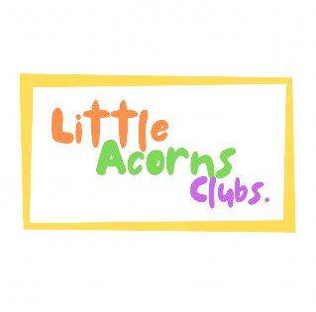

LITTLE ACORNS CLUBS

(Little Acorns Out of School Club Ltd)
Raised Temperature and Pain Relief Policy

If your child complains of feeling unwell and hot, we will take their temperature with a digital thermometer. If their temperature is above 37.5 °C, we are happy to administer children’s paracetamol in an attempt to reduce their temperature to 37 °C.
Should your child’s temperature continue to increase, we will contact you in order that you can collect your child and seek medical advice.
If you are happy for the Club to administer children’s paracetamol to your child if she/he/they have a raised temperature or for the benefit of pain relief, please select YES on the registration page – This information will be retained until such times that it is required. There is also an option to select NO at point of registration.

Created – August 2020
Reviewed / Updated – MARCH 2024

